DSA 0601 - Data handling and visualization
Set 21 - Energy Consumption Dashboard
Name : B.Jahnavi
Reg.no:192325043

1. Import the dataset and plot histogram and density plot
Code:

library(ggplot2)

energy <- read.csv("Energy_Consumption_Data.csv")

ggplot(energy, aes(x = Units_Consumed..kWh.)) +
geom_histogram(
bins = 5,
fill = "skyblue",
color = "black"
) +
labs(
title = "Histogram of Energy Consumption",
x = "Units Consumed (kWh)",
y = "Frequency"
) +
theme_minimal()

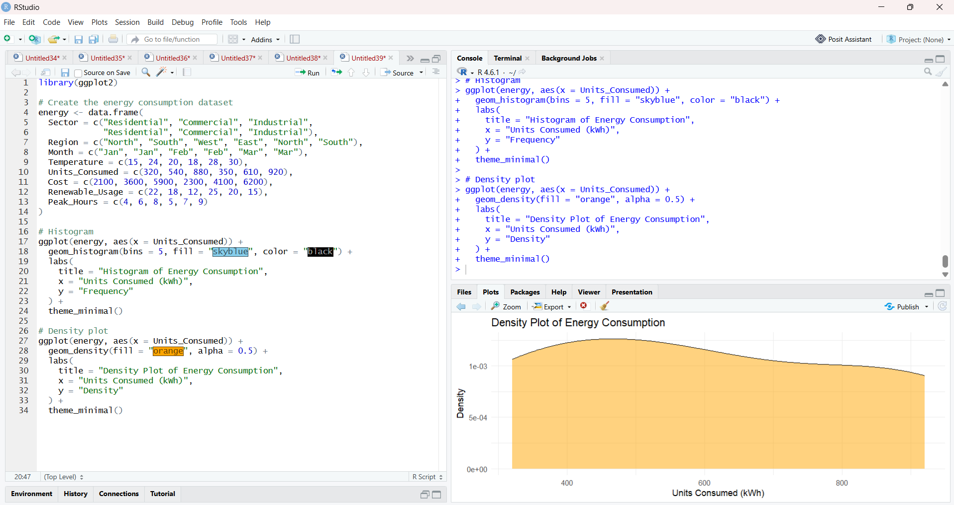

2. Scatter plot with bubble size representing Peak Hours
Code:

library(ggplot2)

ggplot(
energy,
aes(
x = Temperature,
y = Units_Consumed,
size = Peak_Hours,
color = Sector
)
) +
geom_point(alpha = 0.6) +
labs(
title = "Temperature vs Energy Consumption",
x = "Temperature (°C)",
y = "Units Consumed (kWh)",
size = "Peak Hours",
color = "Sector"
) +
theme_minimal()

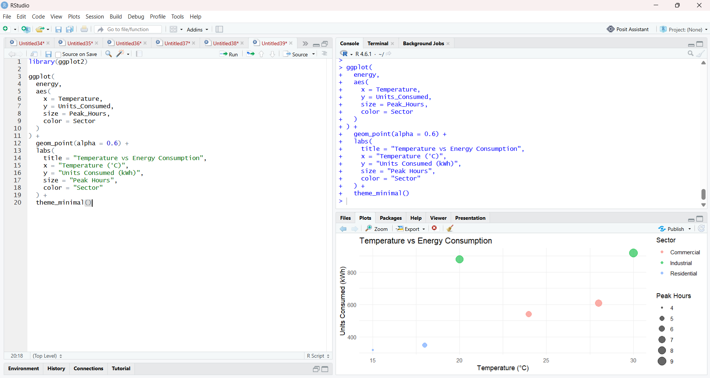

3. Average renewable usage by sector
Code:

library(dplyr)
library(ggplot2)

renewable_avg <- energy %>%
group_by(Sector) %>%
summarise(
Average_Renewable_Usage = mean(Renewable_Usage),
.groups = "drop"
)

ggplot(
renewable_avg,
aes(x = Sector, y = Average_Renewable_Usage, fill = Sector)
) +
geom_col() +
geom_text(
aes(label = paste0(round(Average_Renewable_Usage, 1), "%")),
vjust = -0.5
) +
labs(
title = "Average Renewable Energy Usage by Sector",
x = "Sector",
y = "Average Renewable Usage (%)"
) +
theme_minimal()

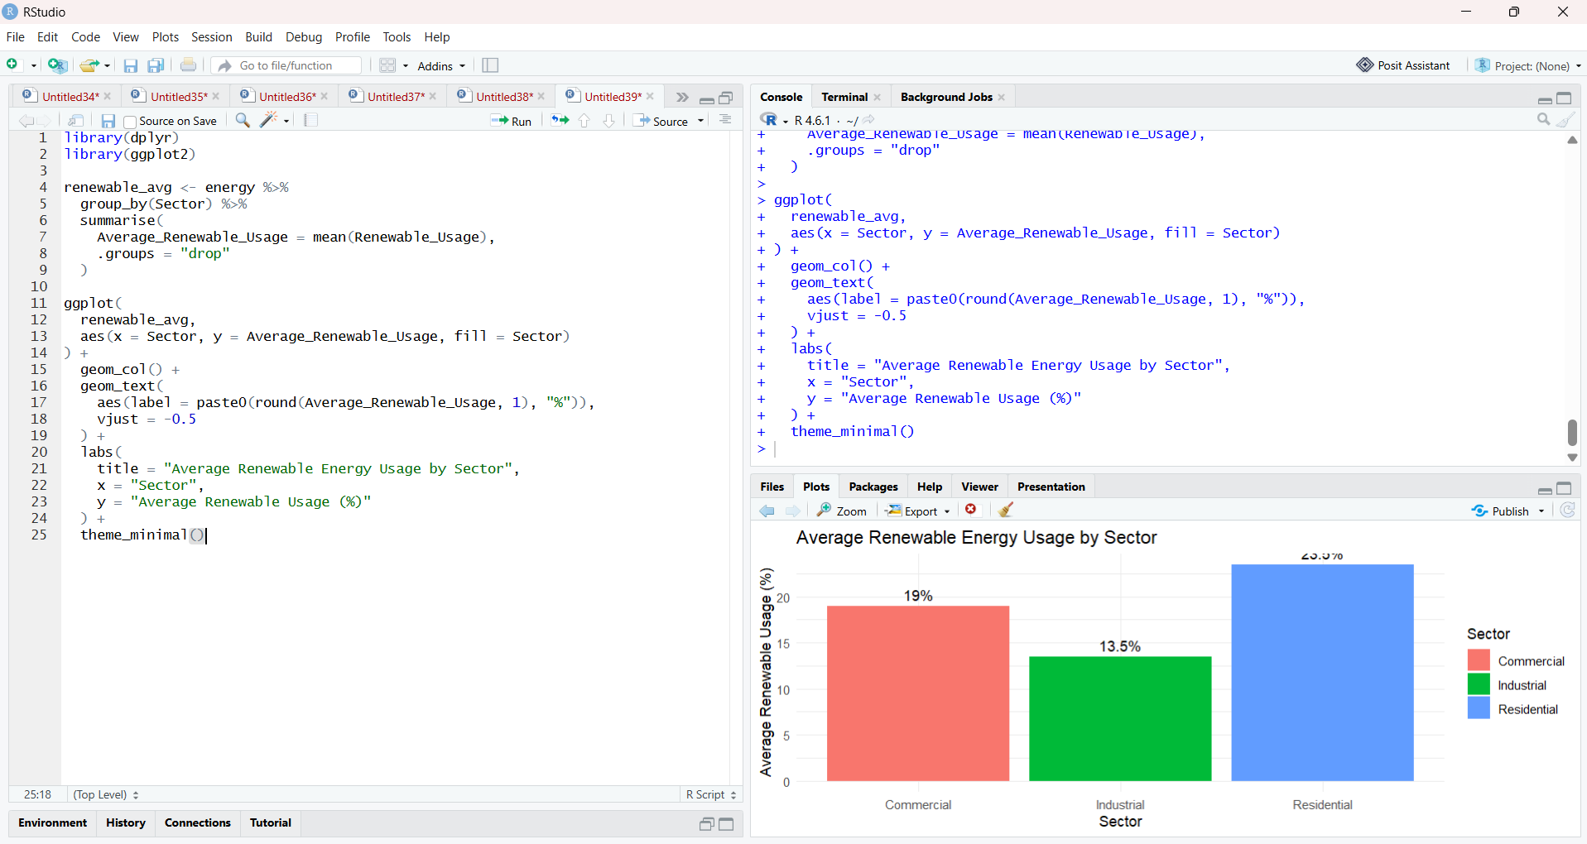

4. Tableau dashboard
Code:

energy <- data.frame(
Sector = c("Residential", "Commercial", "Industrial",
"Residential", "Commercial", "Industrial"),
Region = c("North", "South", "West", "East", "North", "South"),
Month = c("Jan", "Jan", "Feb", "Feb", "Mar", "Mar"),
Temperature = c(15, 24, 20, 18, 28, 30),
Units_Consumed = c(320, 540, 880, 350, 610, 920),
Cost = c(2100, 3600, 5900, 2300, 4100, 6200),
Renewable_Usage = c(22, 18, 12, 25, 20, 15),
Peak_Hours = c(4, 6, 8, 5, 7, 9)
)
write.csv(energy, "Set21_Energy_Consumption.csv", row.names = FALSE)

